**Week 12-01:**

**Name:Snehan.S**

**Roll no:241801272**

1. **.** A binary number is a combination of 1s and 0s. Its nth least significant digit is the nth digit starting from the right starting with 1. Given a decimal number, convert it to binary and determine the value of the the 4th least significant digit.

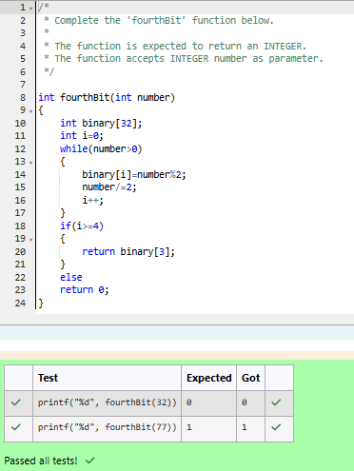

2. Find the number of ways that a given integer, X, can be expressed as the sum of the Nth powers of unique, natural numbers. For example, if X = 13 and N = 2, we have to find all combinations of unique squares adding up to 13. The only solution is 22 + 32. Function Description Complete the powerSum function in the editor below. It should return an integer that represents the number of possible combinations. powerSum has the following parameter(s): X: the integer to sum to N: the integer power to raise numbers to

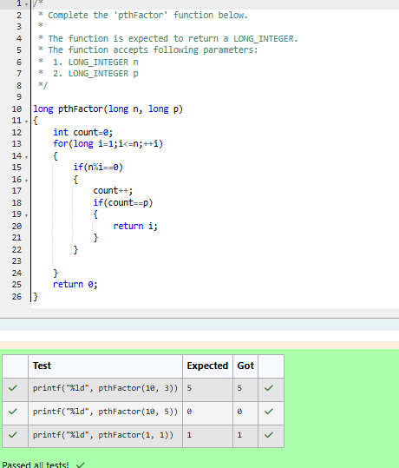

**3**. You are a bank account hacker. Initially you have 1 rupee in your account, and you want exactly N rupees in your account. You wrote two hacks, first hack can multiply the amount of money you own by 10, while the second can multiply it by 20. These hacks can be used any number of time. Can you achieve the desired amount N using these hacks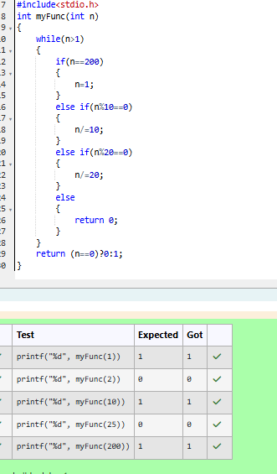

4. Find the number of ways that a given integer, X, can be expressed as the sum of the Nth powers of unique, natural numbers

